OXYGEN PRECIPITATION IN CZOCHRALSKI SILICON

J. Šik (a), Z. Bochníček (b)

- ON SEMICONDUCTOR CZECH REPUBLIC, Rožnov p.R., jan.sik@onsemi.cz
- Dept. of General Physics, Faculty of Science, MU Brno, Czech Republic

The formation of defects in ultra high purity Czochralski (CZ) silicon is a key issue in the evolution of crystal growth methods and microelectronic device manufacturing. Especially oxygen precipitates can serve as beneficial gettering centers, if properly engineered and that is why their growth and annealing optimization is of great importance.
Oxygen is introduced into crystal during CZ crystal pulling. The melt is in contact with surface of the quartz crucible, which is gradually dissolved as a result of reaction Si+SiO₂→2SiO. This reaction enriches the silicon melt with oxygen. Most of the oxygen atoms evaporate from the melt surface as volatile silicon monooxide, but some of them incorporate into a silicon crystal through the crystal melt interface [1]. Near silicon melting point (1412°C) oxygen dissolves in solid silicon at concentrations ∼10¹⁸ atoms/cm³ by forming two strong Si-O bonds with nearest neighbor Si atoms. In this configuration, it is considered as interstitial and denoted O_{i}. Example of typical interstitial oxygen content along the silicon ingot is in Fig. 1. Due to this dependence and different thermal history of each crystal part, we observe strong dependence of oxygen precipitation capability in silicon ingot.
FIG. 1: Example of interstitial oxygen content in the slightly doped 6” (150mm) diameter silicon ingot.

The aim of defect engineering work is in creating precipitates with a uniform size and density positioned just below defect-free denuded zone (DZ) in device active region for all wafers from crystal. In this case, precipitates can locally and really effectively reduce unwanted metallic impurities from DZ. Internal oxidation and subsequent metal impurity trapping known as internal gettering (IG) often occurs in CZ silicon during conventional manufacturing cycles and is dependent on the thermal history during crystal growth, micro-defect distribution and also presence of carbon within wafer [2]. Integrated circuit (IC) process engineer and wafer vendor field engineer usually work on optimization of thermal steps for specific product.
In this paper we present results of thermal cycles optimization for new technology of IC manufacturing. Samples (6” Si wafers slightly doped with boron) were selected from 5 positions in the crystal body, starting from crown-end up to tail-end of the crystal. Each group of 5 wafers was annealed with one out of three different high-temperature steps:
- precipitation test (750°C /4hrs. + 1050 °C /16hrs.),
- new technology high-temperature steps,
- 750°C /4hrs. + new technology high-temperature steps.
Oxygen precipitates were analyzed with X-ray section topography, X-ray difraction, selective etching (see Fig. 2), and infra-red transmittance [3].

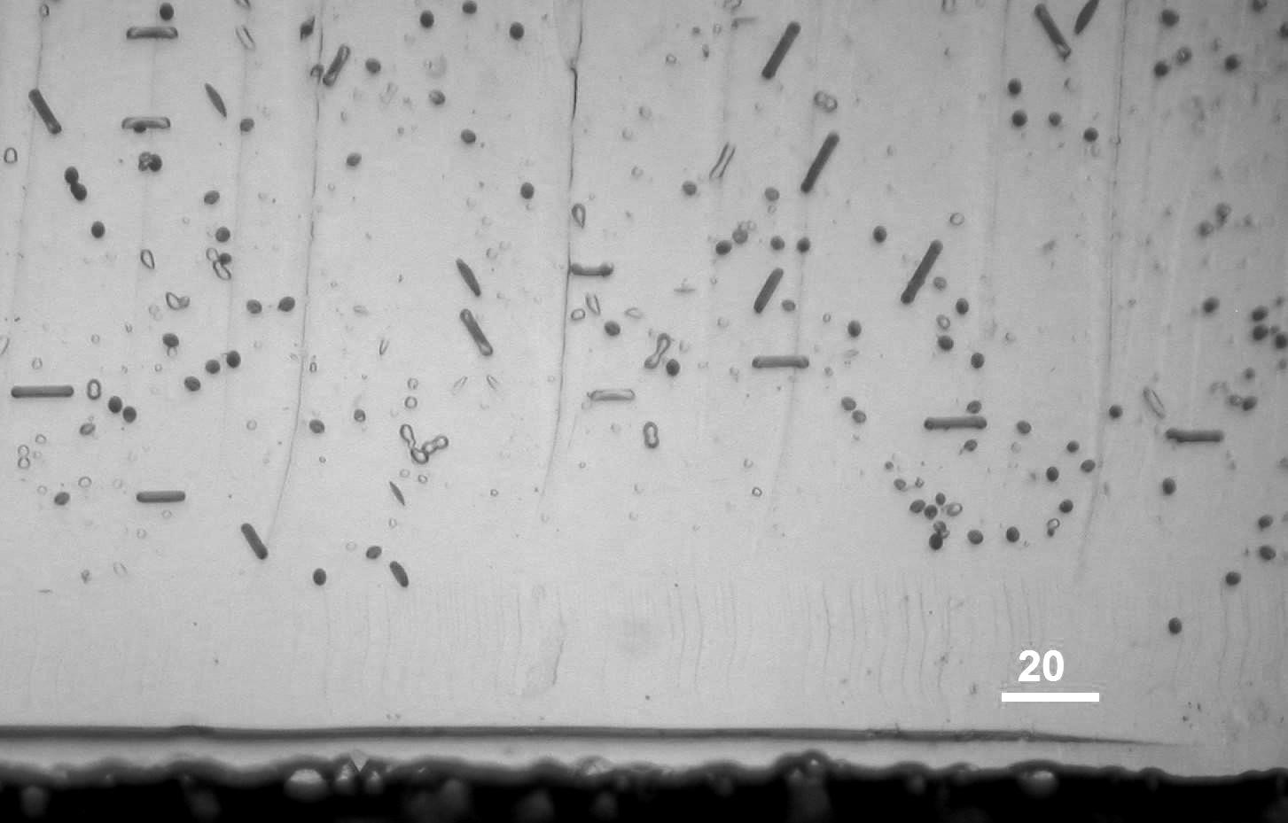
μm
FIG. 2: Example of wafer cross section etched 2 min. at room temperature in Secco [4] solution. Observed defects are related to oxygen precipitation in the wafer bulk. Wafer surface is in the bottom of the picture. Defect free DZ (∼30 μm thick) is visible in the picture.

Analyses revealed strong precipitation dependence along ingot. Oxygen in wafers from the crown-end precipitates much more than in wafers from the rest of the crystal, especially for A-set of wafers. Precipitation for B-set of wafers was low for all 5 wafers. Additional nucletion step (750°C/4hrs.) increased precipitation level compared to set B and we observed clear denuded zone (30-50 μm thick) for all 5 wafers from set C. In conlusion, thermal budget of new technology is not suitable for proper oxygen precipitation in the substrate and it is recommended to add nucletion step at 750°C into IC manufacturing thermal budget.

[1] F. Shimura, Semiconductor Silicon Crystal Technology, Academic Press (1989), 162.
[2] G. A. Rozgonyi, Control of point defects, impurities, and extended defects in CZ Si, in Electrochem. Soc. Proceedings, Vol. 2002-2, ed. H. R. Huff, L. Fabry, S. Kishino (2002) 149.
[3] Z. Bochníček, P. Klang, J. Kuběna, R. Štoudek, Study of micro-defects in silicon, LDDA* internal report, MU Brno, in Czech (2005).
[4] F. Secco d´Aragona, J. Electrochem. Soc. 119 (1972), 948.

* LDDA – Joint laboratory VUT and MU Brno with ON SEMICONDUCTOR CZECH REPUBLIC „Laboratory of defect diagnostics and surface analyses“.

